# SOP FOR

1. **PURPOSE: Maintenance of Crane in safe way for optimum performance**
2. **SCOPE:** **All EOT cranes .**
3. **RESPONSIBILITY: Engineer In charge and workmen on duty.**
4. **PROCEDURE: MAINTENANCE OF ELECTRICALLY OPERATED OVERHEAD CRANE.**

________________________________________________________________________________

* - PPE –s to be used:
* Helmet, Safety shoes, Dust mask, safety goggle and full body safety harness (while working at height).

* Work No 1 : Crane coupling checking/changing
* Work No 2 : Crane gear box/motor/ drum replacement
* Work No 3  : Crane wire rope changing
* Work No 4  : Crane hook changing
* Work No 5 :Wire rope lubrication
* Work No 6 :Wire rope preparation
* Work No 7 :Wire rope Inspection
* Work No 8 :Grab bucket replacement
* Work No 9 :Wheel assembly changing
* Work No 10 :Wheel assembly overhauling
* Work No 11 :Bearing lubrication
* Work No 12 :Visual inspection of cranes

Aspect - Impact

|  |  |
| --- | --- |
| Oil Spillage | ; Land contamination & Resource Depletion |
| Dust Generation | : Air pollution |
| Oil traced waste generation | ; Land contamination & Resource Depletion |

Hazards identified

Mechanical Hazard

1.     Fall of person from height.

2.     Fall of person in hot water.

3.     Slipping of person in graphite or grease.

4.     Trapping of person during the fall of material from crane height.

5.     Trapping of person between crane wheel/ structure and rail.

6.     Trapping of person between the HIAB basket and the crab.

7.     Trapping of hand between the brake assembly gaps.

8.     Hitting/trapping of person between two cranes or between crane and structure.

9.     Hitting of person by crane while moving (standing on crane or while standing in walkway).

10.  Trapping of hand/ other part of body while handling the material or equipment.

11.  Hitting/ trapping of person by material being lifted by external crane/ hydra.

12.  Hitting of ladle or hook while shifting / crane moving.

13.  Fall of material from top.

14.  Fall of spanners, tools, plate, angles, open wire rope while lifting rope, steel etc.

15.  Fall of equipment like gearbox, motor etc. while installation.

16.  Failure of wire rope/sling while lifting wire rope, gearbox, motor, stseel etc.

17.  Failure of wire rope/ hook of external crane/ Hydra used for material/ equipment erection.

18.  Failure of lifting machines, handling machines such as chain pulley block, sling, D shackle etc.

19.  Back Pain due to sudden or heavy load like gear boxes, drums & motors etc.

20.  Non use of PPE’s while carrying out the activity.

21.  Alcoholism.

22.  Trapping.

23.  Failure of crane hook and hook coming out due to lock plate failure or loosening.

24.  Structural failure in crane.

25.  Hitting of moving machineries like crane, truck, wheel loader etc while reversing or taking forward

26.  Failure of brake, gear & couplings.

27.  Failure EOT crane wire rope

28.  Impact of other moving EOT cranes which are in operation on the crane under maintenance

29.  Slip or fall or any accidents on account of poor visibility due to steam from mould cooling or slag granulation

30.  Fall or slip of crane while jacking

31.  Incident due to improper identification of cranes or drives

32.  Fall of person through the gate provided for entering into crane

33.  Accident due to improper operation or wrong signaling

34.  Accident due to faulty operation of remote.

35.  Accident due to operation from other operating points

36.  Trapping of fingers in brake

37.  Trapping of fingers between rope and rope drum

38.  Failure of manila rope used for lifting the wire rope

39.  Fall of wire rope while lifting the wire rope or nay other items due to improper tying or negligence of person holding it

40.  Fall of person while checking the tension of wire ropes of all cranes of BF3

41.  Failure of jack

Physical Hazard

1.     Fire.

2.     Graphite and dust falling in eyes.

3.     Exposure to hot metal/slag splatters.

1. Exposure of person to hot slag granulation water.
2. Exposure to slag granulation or PCM fumes.
3. Hitting of bearing pieces.
4. Impact of chips in eyes or any body part while working near PCM area
5. Burn injury from hot metal splashing or spillage
6. Explosion of hot metal
7. Fire of lubricating compound

Chemical Hazard

1.     BF Gas

Electrical Hazard

1. Electrical shock.
2. Electric shock due to DSL bars.

Human Behavior

1. Workmen under influence of alcohol
2. Violation of procedure
3. Not wearing PPE’s
4. Not concentrating while working
5. Horseplay

**General guide lines**

1. **Take shutdown of DSL when ever working in the vicinity of DSL**
2. **Take clearance from production department (Work Permit) from the shift Superintendent / Area In charge.**
3. **Obtain the shutdown clearance from Electrical Department as per Format FRMT/ELECT/06.**
4. **Cordon the full area at the ground, which is coming under the approach of the crane. Ensure that dismantled hardware are handled carefully to avoid fall from height.**
5. **Empty or fill the oil to gearbox as per requirement with care to avoid spillage.**
6. **After completion of the job restore all safety guards, take electrical clearance and complete the restoration of equipment as per shut down procedure.**
7. **Return back all waste oil to store for proper disposal/recycling.**
8. **Carry out housekeeping as per the procedure . No loose material to be kept in cranes or platforms**
9. **Refer WI/MAINT/12 & SP 44 for material handling**
10. **Refer WI/MAINT/ 94 for fabrication and erection jobs.**

Work No 1: Crane Coupling Checking/ Changing

1. .

**Work No 1: Procedure**

1. **Take Permission from Operations SS**
2. **Take electrical shutdown of the crane.**
3. **Take work permit from operation.**

**B.    Remove the coupling guard and de couple the coupling.**

**C.    Check the coupling teeth on the hub and flange for wear out.**

**D.    Check the coupling for looseness on shaft and keyway.**

**E.     If the teeth have sharpened or coupling found loose on shaft, then change the coupling.**

**F.     Remove the coupling using the coupling puller.**

**G.    Take the actual dimension of the shaft and machine the coupling internal bore as per these dimensions.**

**H.    Fit back coupling along with the key**

**I.       Fit back motor to the position.**

**J.      Align the coupling axis of motor and gearbox.**

**K.    Fill grease in the coupling and couple the coupling. Take due care to avoid any spillage of grease on ground.**

**L.     Clear the electrical shutdown as per shutdown procedure and take trials.**

**M.   Take the trial of the same for forward / reverse direction and Hoisting / lowering. After that Close the work permit.**

**N.    Following additional cares must be taken while checking the coupling in running cranes:**

**-        Take electrical shutdown and tighten the bolts. Never ever loosen the coupling bolts when crane is loaded with ladle**

**-        Close co-ordination with crane operator and engineer in charge is essential while going into crane during running**

DO

* Barricade the area below working area.

    Ensure the usage of dust mask and safety goggles in dusty areas. After cleaning the grease dispose the cotton waste as per procedure.

* Ensure to get the crane area cleaned of Graphite dust before starting maintenance works on crane

DONOT

* Wipe grease from your hand to any structure.
* Forget to put back the coupling guard.

Work No 2 : Crane Gearbox/Motor/ Rope Drum Replacement

Hazards identified

Mechanical Hazard

1.     Fall of person from height.

2.     Fall of person in hot water.

3.     Slipping of person in graphite or grease.

4.     Trapping of person during the fall of material from crane height.

5.     Trapping of hand between the brake assembly gap.

6.     Hitting/trapping of person between two cranes or between crane and structure.

7.     Hitting of person by crane while moving ( standing on crane or while standing in walkway).

8.     Trapping of hand/ other part of body while handling the material or equipment.

9.     Hitting/ trapping of person by material being lifted by external crane/ hydra.

10.  Hitting of ladle or hook while shifting / crane moving.

11.  Fall of material from top.

12.  Fall of spanners, tools, plate, angles, open wire rope while lifting rope, steel etc.

13.  Fall of equipment like gearbox, motor etc. while installation.

14.  Failure of wire rope/sling while lifting wire rope, gearbox, motor, steel etc.

15.  Failure of wire rope/ hook of external crane/ Hydra used for material/ equipment erection.

16.  Failure of lifting machines, handling machines such as chain pulley block, sling, D shackle etc.

17.  Back Pain due to sudden or heavy load like gear boxes, drums & motors etc.

18.  Non use of PPE’s while carrying out the activity.

19.  Alcoholism.

20.  Trapping.

21.  Hitting of moving machineries like crane, truck, wheel loader etc while reversing or taking forward

22.  Impact of other moving EOT cranes which are in operation on the crane under maintenance

23.  Slip or fall or any accidents on account of poor visibility due to steam from mould cooling or slag granulation

24.  Incident due to improper identification of cranes or drives

25.  Fall of person through the gate provided for entering into crane

26.  Accident due to improper operation or wrong signaling

27.  Accident due to faulty operation of remote.

28.  Accident due to operation from other operating points

29.  Trapping of fingers in brake

30.  Trapping of fingers between rope and rope drum

31.  Fall of wire rope while lifting the wire rope or nay other items due to improper tying or negligence of person holding it

Physical Hazard

1.     Graphite and dust falling in eyes.

2.     Exposure to hot metal/slag splatters.

1. Exposure of person to hot slag granulation water.
2. Exposure to slag granulation or PCM fumes.
3. Impact of chips in eyes or any body part while working near PCM area
4. Burn injury from hot metal splashing or spillage
5. Explosion of hot metal

Electrical Hazard

1.     Electrical shock.

2.     Electric shock due to DSL bars.

**Work No 2: Procedure**

A. Take electrical shutdown of DSL& Work permit.

**B.    Remove the coupling guard and decouple the coupling to isolate drive and driven unit.**

**C.    Ensure the proper slinging of motor on hooks, gear box & drum etc. Remove the electrical connection of the motor.**

**D.    Remove the foundation bolt of motor/gear box/ rope drum.**

**E.    Lift and lower the gear box/ motor/rope drum using chain block/external crane. Follow procedure of material handling for application (**[**WI/MAINT/12**](http://sgl-panj-sp-01:8080/../../../../Dipesh/balkrishna/Local%20Settings/Temporary%20Internet%20Files/Content.IE5/departmental%20manual/11%20%20Work%20instruction/WIMAINT12%20MATERIAL%20HANDLING%20.doc)**).**

**F.     Fit back new overhauled gear box/ motor to the position .Give electrical connection to the motor**

**G.     Align the driving and driven unit.**

**H.    Couple the drive and driven unit. Fix the coupling guard back to position. After completion of job make sure all are keep in their position .**

**I.    Clear the electrical shutdown as per procedure & Take the trial of the unit**.

DO

ü     Barricade the area below working area.

ü     Use testing lifting tools and tackles.

ü     Ensure the usage of dust mask and safety goggles in dusty areas.

DO NOT

ü     Wipe grease of our hand by rubbing against any structure.

ü     Forget to put back the coupling guard.

Work No 3 : Wire Rope Changing

Hazards identified

Mechanical Hazard

1.     Fall of person from height.

2.     Fall of person in hot water.

3.     Slipping of person in graphite or grease.

4.     Trapping of person during the fall of material from crane height.

5.     Trapping of hand between the brake assembly gap.

6.     Hitting/trapping of person between two cranes or between crane and structure.

7.     Hitting of person by crane while moving ( standing on crane or while standing in walkway).

8.     Hitting of ladle or hook while shifting / crane moving.

9.     Fall of material from top.

10.  Fall of spanners, tools, plate, angles, open wire rope while lifting rope, steel etc.

11.  Back Pain due to sudden or heavy load like gear boxes, drums & motors etc.

12.  Non use of PPE’s while carrying out the activity.

13.  Alcoholism.

14.  Trapping.

15.  Hitting of moving machineries like crane, truck, wheel loader etc while reversing or taking forward

16.  Failure EOT crane wire rope

17.  Impact of other moving EOT cranes which are in operation on the crane under maintenance

18.  Slip or fall or any accidents on account of poor visibility due to steam from mould cooling or slag granulation

19.  Incident due to improper identification of cranes or drives

20.  Fall of person through the gate provided for entering into crane

21.  Accident due to improper operation or wrong signaling

22.  Accident due to faulty operation of remote.

23.  Accident due to operation from other operating points

24.  Trapping of fingers in brake

25.  Trapping of fingers between rope and rope drum

26.  Failure of manila rope used for lifting the wire rope

27.  Fall of wire rope while lifting the wire rope or any other items due to improper tying or negligence of person holding it

28.  Fall of person while checking the tension of wire ropes of all cranes.

Physical Hazard

1.     Graphite and dust falling in eyes.

2.     Exposure to hot metal/slag splatters.

1. Exposure of person to hot slag granulation water.
2. Exposure to slag granulation or PCM fumes.
3. Impact of chips in eyes or any body part while working near PCM area
4. Burn injury from hot metal splashing or spillage
5. Explosion of hot metal
6. Fire of cardium compound

Electrical Hazard

1. Electrical shock.
2. Electric shock due to DSL bars.

**BF3 Hot Metal Crane (100T) Wire Rope Changing**

1. **Take work permit from operation .Barricade the area under the crane with WORK IN PROGRESS TAPE.**
2. **Lower the 100Tpulley block fully till the J hook touches the ground.**
3. **Make slight LT movement of the crane in order to tilt the 100T hook.**
4. **Slowly lower the 100T “J” hook horizontally on the ground.**
5. **Now disengage the “ J” hook assembly from snatch block**
6. **Lower snatch block on ground in vertical position & lock the same with welding support**

**Note: Direct earthing needs to be given while welding as can be seen in below photo.**

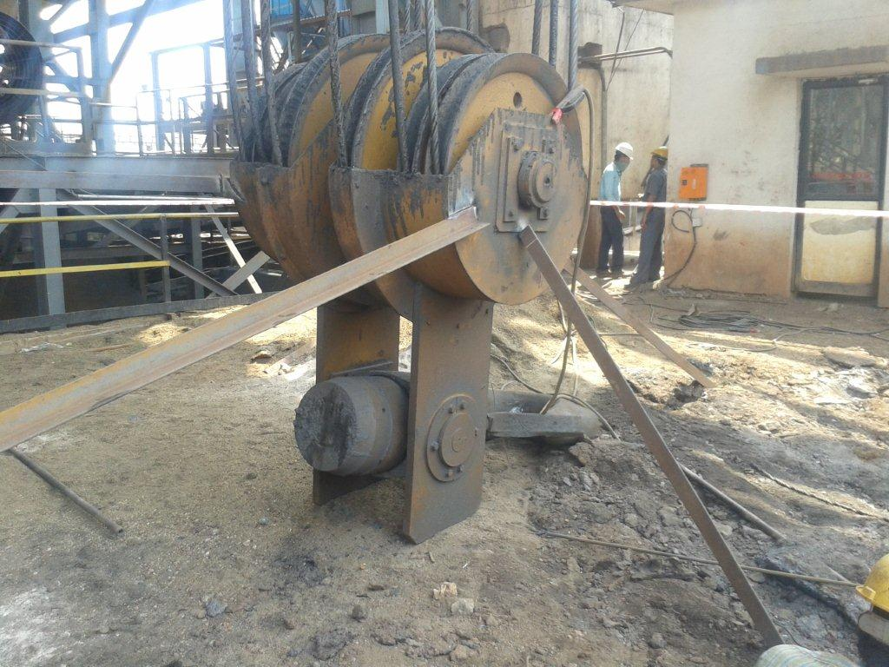

1. **Take electrical shutdown of the crane. Take only shut down of LT .**
2. **Properly arrest the wire rope with manila rope and remove the hinge thimble pins, lower both side hinge rope on ground by gradually lowering the manila rope.**
3. **Take both ends of new & old wire rope each & weld prefabricated“ U” rings then clamp it with endless sling.(clamping should be flexible and within the diameter of the wire rope)**

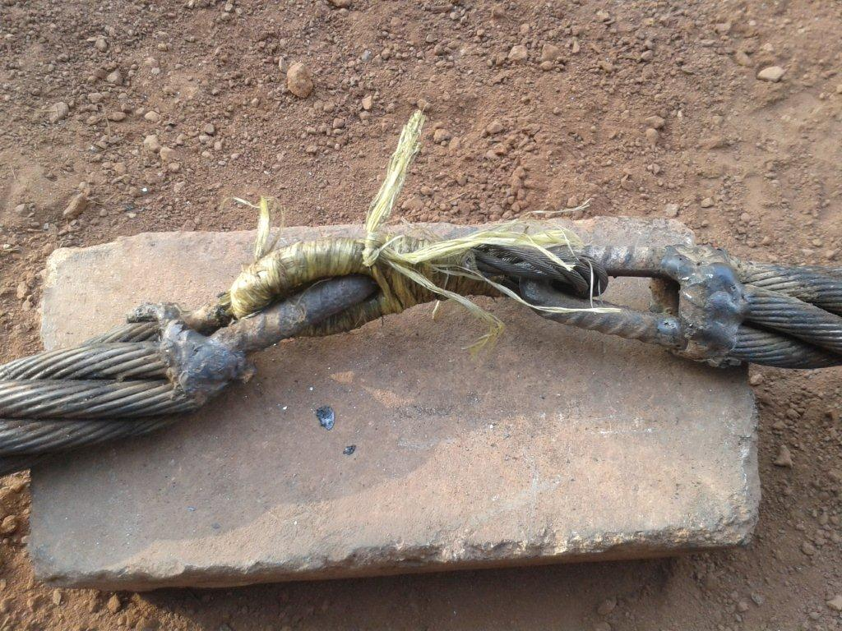

Endless wire sling

1. **Temporary clear electrical shut down of the crane.as per procedure**
2. **Start hoisting the main hoist drum by inching till new end of wire rope comes out from all the pulleys and winds 3 rounds on main wire rope drum.**
3. **Tie the hoisted rope to nearby structure firmly.**
4. **Disconnect the joint between old & new rope .Tie the new rope to the near by structure.**
5. **Remove the clamps on the wire rope drum.**
6. **Lower the wire rope on the ground using manila rope and ensuring no person standing under the crane.**
7. **Start laying the wire rope on the drum and clamp it firmly.**
8. **Clear electrical shutdown and also remove by pass of lower limit switch.**
9. **Slowly wind the 100T wire rope on rope drum, taking care that the wire rope should not come out of the pulley grooves of snatch box.**
10. **Take trial by lifting and lowering empty ladle. Then apply wire rope lubrication .**
11. **Ensure that both limit switches are working and at the original levels of hoisting**

**Hot Metal Crane auxiliary hoist, cast house Crane Hoist, Blower house main and auxiliary hoist**

1. **Take work permit from operation &Barricade the area under the crane with WORK IN PROGRESS TAPE.**
2. **Get the lower limit switch by passed by electrical engineer/electrician.**
3. **Lower the hook fully on ground till the hook becomes horizontal on ground.**
4. **Continue lowering the wire rope till only 2 round of rope is remaining on the rope drum**
5. **Take electrical shutdown of the crane. Only take shut down of LT .**
6. **Remove the clamps on the wire rope drum.**
7. **Lower the wire rope on the ground ensuring no person standing under the crane.**
8. **Start laying the wire rope as per the respective General Arrangement Drawing.**
9. **Make sure that the wire rope is passed through the gravity limit switch.**
10. **Clamp the ends of wire rope properly on rope drum.**
11. **Apply wire rope lubricant if necessary.**
12. **Clear electrical shutdown and also remove by pass of lower limit switch.**
13. **Take trial by lifting and lowering**
14. **Ensure that the limit switches are working.**

**Grab Crane Wire Rope Changing**

1. **Open the bucket fully and lower on ground**
2. **Operate open lower to unwind the wire rope from the rope drum upto to limiting position.**
3. **Take electrical shutdown of the crane**
4. **Remove the clamp from wire rope drum.**
5. **Lay the rope as per General Arrangement Drawing.**
6. **Put bulldog clamps at the wire rope end.**
7. **Ensure that there as 2 bull dog clamps for each wire rope.**
8. **Clear the electrical shutdown and slowly start hoisting the bucket.**
9. **Once the bucket is hoisted, close the bucket.**
10. **If hoist wire ropes are replaced ensure that the bucket is in horizontal.**
11. **If open close wire rope is replaced the pulley block should be horizontal.**
12. **Ensure that all 4 wire ropes should be in equal tension when the bucket is closed fully.**
13. **First take trial with empty bucket and then with slag/iron ore**

DO

ü     Barricade the area below working area.

ü     Ensure the usage of dust mask and safety goggles in dusty areas.’

ü     keep 1 person standing outside the barricaded area to prevent people entering the barricaded area.

ü     Ensure that there is no person standing under the crane

ü     Due care to avoid falling of material from top.

ü     Ensure removal of limit switch by pass after finishing the job.

DO NOT

ü     Do not keep any loose part/clamp on the crane.

ü     Stand under the crane when rope is loosened from clamps

ü     Climb on the rope drum;

ü     Carry out the job when cast/ blowing slag granulation is going on

Work No 4: Crane hook changing

Hazards identified

Mechanical Hazard

1.     Trapping of person during the fall of material from crane height.

2.     Trapping of hand/ other part of body while handling the material or equipment.

3.     Hitting/ trapping of person by material being lifted by external crane/ hydra.

4.     Hitting of ladle or hook while shifting / crane moving.

5.     Fall of material from top.

6.     Fall of spanners, tools, plate, angles, open wire rope while lifting rope, steel etc.

7.     Fall of equipment like gearbox, motor etc. while installation.

8.     Failure of wire rope/sling while lifting wire rope, gearbox, motor, steel etc.

9.     Failure of wire rope/ hook of external crane/ Hydra used for material/ equipment erection.

10.  Failure of lifting machines, handling machines such as chain pulley block, sling, D shackle etc.

11.  Back Pain due to sudden or heavy load like gear boxes, drums & motors etc.

12.  Non use of PPE’s while carrying out the activity.

13.  Alcoholism.

14.  Trapping.

15.  Hitting of moving machineries like crane, truck, wheel loader etc while reversing or taking forward

16.  Failure EOT crane wire rope

17.  Impact of other moving EOT cranes which are in operation on the crane under maintenance

18.  Slip or fall or any accidents on account of poor visibility due to steam from mould cooling or slag granulation

19.  Incident due to improper identification of cranes or drives

20.  Accident due to improper operation or wrong signaling

21.  Accident due to faulty operation of remote.

22.  Accident due to operation from other operating points

Physical Hazard

1.     Graphite and dust falling in eyes.

2.     Exposure to hot metal/slag splatters.

1. Exposure to slag granulation or PCM fumes.
2. Impact of chips in eyes or any body part while working near PCM area
3. Burn injury from hot metal splashing or spillage
4. Explosion of hot metal

Electrical Hazard

1. Electric shock
2. Shock from DSL

**For removing Main hook (Hot Metal crane)**

**A.    Take work permit from the operation department. Barricade with tape. Lower the snatch box to the ground & ditched it from the j hooks**

**B.    Use auxiliary hook/hydra to reduce the hook tension on the pin**

**C.   Remove the locking arrangement of the hook from snatch box.**

**D.   Separate the hook from the assembly.**

**E.    Position the new hook so that locking pin passes thought the hole.**

**F.    Lock the hook with locating pins and stoppers.**

**G.  Take the trial of hook by lifting empty ladle**.

**For removing 20T, 16T, 32/5T hook**

1. **Take work permit from the operation department.Lower the whole hook on the ground.**
2. **Remove the locking arrangement of the hook. After taking electrical shutdown of LT.**
3. **Separate the hook from the assembly.**
4. **Position the new hook so that locking pin passes thought the hole.**
5. **Ensure that the hook is tightened fully in the nut and the top faces of hook & nut are in same level.**
6. **Also ensure that the locking plate passes through the groove on hook as well as on nut and lock nuts are tightened fully**
7. **Take the trial of hook by lifting empty ladle**

DO

* Ensure the locking of pin with locking plates.
* Ensure locking of hook and nut with locking plate

Work No 5 : Wire Rope Lubrication

Hazards identified

Mechanical Hazard

1.     Fall of person from height.

2.     Fall of person in hot water.

3.     Slipping of person in graphite or grease.

4.     Trapping of person between the HIAB basket and the crab.

5.     Trapping of hand between the brake assembly gap.

6.     Hitting/trapping of person between two cranes or between crane and structure.

7.     Hitting of person by crane while moving ( standing on crane or while standing in walkway).

8.     Hitting of ladle or hook while shifting / crane moving.

9.     Fall of material from top.

10.  Non use of PPE’s while carrying out the activity.

11.  Alcoholism.

12.  Trapping.

13.  Hitting of moving machineries like crane, truck, wheel loader etc while reversing or taking forward

14.  Failure of brake, gear & couplings.

15.  Failure EOT crane wire rope

16.  Impact of other moving EOT cranes which are in operation on the crane under maintenance

17.  Slip or fall or any accidents on account of poor visibility due to steam from mould cooling or slag granulation

18.  Incident due to improper identification of cranes or drives

19.  Fall of person through the gate provided for entering into crane

20.  Accident due to improper operation or wrong signaling

21.  Accident due to faulty operation of remote.

22.  Accident due to operation from other operating points

23.  Trapping of fingers in brake

24.  Trapping of fingers between rope and rope drum

Physical Hazard

1.     Fire.

2.     Graphite and dust falling in eyes.

3.     Exposure to hot metal/slag splatters.

4.     Exposure of person to hot slag granulation water.

5.     Exposure to slag granulation or PCM fumes.

6.     Impact of chips in eyes or any body part while working near PCM area

7.     Burn injury from hot metal splashing or spillage

8.     Explosion of hot metal

9.     Fire of Cardium compound

Electrical Hazard

1.     Electrical shock.

2.     Electric shock due to DSL bars.

1. **Take work permit from the operation the wire rope fully.**
2. **Ensure that the hook snatch box or pulley block or grab bucket will not touch the crab.**
3. **Clean the graphite accumulate on the drum with cotton cloth & dispose the cloth as per procedure**
4. **Apply the lubricant with brush.**
5. **Once the lubricant is applied rotate the drum and apply it on other side of the drum.**
6. **Lower the wire rope and apply lubricant on the rope drum and again wind the rope so to apply the lubricant on the other side of wire rope.**

DO

* Barricade the area below working area.
* Ensure the usage of dust mask and safety goggles in dusty areas.
* Ensure that there is no person standing under the crane
* Due care to avoid falling of material from top.
* Ensure removal of limit switch by pass after finishing the job.
* Wear safety belt when climbing the HIAB basket.
* Carry EOT crane remote and HIAB remote with you when in basket.

DONOT

* Stand under the crane when rope is being lubricated
* Climb the rope drum

Work No 6 : **Wire Rope Preparation**

Hazards identified

Mechanical Hazard

1.     Hitting/ trapping of person by material being lifted by external crane/ hydra.

2.     Back Pain due to sudden or heavy load like gear boxes, drums & motors etc.

3.     Non use of PPE’s while carrying out the activity.

4.     Alcoholism.

5.     Trapping.

Physical Hazard

1.     Fire.

Electrical Hazard

* 1. Electrical shock.

1. **. Put the strand opposite the wire rope drum & unwind the rope and put on the new drum after measurement about 20 mtr and roll .again unwind about 20 mtr and roll on the new drum and continue the process till get the required length.**
2. **While unwinding take care that the wire rope should not have any twist.**
3. **If twist is there then remove the twist and then pull the wire rope, else there will a knot and this will damage the wire rope**
4. **Cut he wire rope with the help of gas cutter/welding holder/grinder**
5. **While cutting the wire tie 2 binding wires 50 mm apart and cut at the center**
6. **Following are the length and dia of wire rope which are used on cranes**

**BF3 Hot Metal Crane 100T  32 mm dia and 158X2 m long**

**BF3 Hot Metal Crane 20T  18 mm dia and 220 m long**

**Cast house crane 16T   18 mm dia and 120 m long**

**Blower house crane 32T   22 mm dia and 185 m long**

**Blower house crane 5T 14 mm dia and 162 m long**

**Grab Cranes Open/Close 18 mm dia and 40 m long**

**Grab crane hoist 10T 18 mm dia and 35m long**

1. **After getting the required length of wire rope shift the wire and store with proper tagging.**

DO

* Use goggles when using chisel/grinder for cutting the wire rope.

DO NOT

* Pull the rope when there is twist in the wire rope.

**Work No 7 : Wire rope Inspection Guidelines**

Hazards identified

Mechanical Hazard

1.     Fall of person from height.

2.     Fall of person in hot water.

3.     Slipping of person in graphite or grease.

4.     Trapping of person between the HIAB basket and the crab.

5.     Trapping of hand between the brake assembly gap.

6.     Hitting/trapping of person between two cranes or between crane and structure.

7.     Hitting of person by crane while moving ( standing on crane or while standing in walkway).

8.     Hitting of ladle or hook while shifting / crane moving.

9.     Fall of material from top.

10.  Fall of spanners, tools, plate, angles, open wire rope while lifting rope, steel etc.

11.  Non use of PPE’s while carrying out the activity.

12.  Alcoholism.

13.  Trapping.

14.  Hitting of moving machineries like crane, truck, wheel loader etc while reversing or taking forward

15.  Failure of brake, gear & couplings.

16.  Failure EOT crane wire rope

17.  Impact of other moving EOT cranes which are in operation on the crane under maintenance

18.  Slip or fall or any accidents on account of poor visibility due to steam from mould cooling or slag granulation

19.  Incident due to improper identification of cranes or drives

20.  Fall of person through the gate provided for entering into crane

21.  Accident due to improper operation or wrong signaling

22.  Accident due to faulty operation of remote.

23.  Accident due to operation from other operating points

24.  Trapping of fingers in brake

25.  Trapping of fingers between rope and rope drum

Physical Hazard

1.     Graphite and dust falling in eyes.

2.     Exposure to hot metal/slag splatters.

1. Exposure of person to hot slag granulation water.
2. Exposure to slag granulation or PCM fumes.
3. Impact of chips in eyes or any body part while working near PCM area
4. Burn injury from hot metal splashing or spillage
5. Explosion of hot metal

Electrical Hazard

1.     Electrical shock.

2.     Electric shock due to DSL bars.

1. Clean the wire rope with cotton rag.
2. The rope diameter is to be checked at the sheaves in snatch box, at rope drum.
3. Check the wire rope diameter with vernier caliper.
4. Replace the rope, if diameter is found less than 90% of nominal diameter
5. Inspect the wire rope for corrosion, breakage of strands
6. Check the tightness of the wire rope clamps.

**Work No 8 : Grab Bucket Replacement**

Hazards identified

Mechanical Hazard

1.     Fall of person from height.

2.     Fall of person in hot water.

3.     Slipping of person in graphite or grease.

4.     Trapping of hand/ other part of body while handling the material or equipment.

5.     Hitting/ trapping of person by material being lifted by external crane/ hydra.

6.     Fall of spanners, tools, plate, angles, open wire rope while lifting rope, steel etc.

7.     Fall of equipment like gearbox, motor etc. while installation.

8.     Failure of wire rope/sling while lifting wire rope, gearbox, motor, steel etc.

9.     Failure of wire rope/ hook of external crane/ Hydra used for material/ equipment erection.

10.  Failure of lifting machines, handling machines such as chain pulley block, sling, D shackle etc.

11.  Back Pain due to sudden or heavy load like gear boxes, drums & motors etc.

12.  Non use of PPE’s while carrying out the activity.

13.  Alcoholism.

14.  Hitting of moving machineries like crane, truck, wheel loader etc while reversing or taking forward

15.  Failure EOT crane wire rope

16.  Slip or fall or any accidents on account of poor visibility due to steam from mould cooling or slag granulation

17.  Incident due to improper identification of cranes or drives

18.  Accident due to improper operation or wrong signaling

Physical Hazard

1.     Fire.

2.     Graphite and dust falling in eyes.

3.     Exposure to hot metal/slag splatters.

4.     Exposure of person to hot slag granulation water.

5.     Exposure to slag granulation or PCM fumes.

6.     Hitting of bearing pieces.

1. Impact of chips in eyes or any body part while working near PCM area
2. Burn injury from hot metal splashing or spillage

Electrical Hazard

1. Electrical shock

**Work No 8 : Procedure**

1. **Take work permit from operation. Open the bucket fully and lower on ground.**
2. **Remove bulldog clamps and dismantle the old wire rope which is clamped on the bucket.**
3. **Place new grab bucket under the reach of CT.**
4. **Move the grab crane CT to bring the crab above the new bucket.**
5. **At each end of the Top pulley shaft vertically fix 2 stoppers and weld to prevent the slipping of the shaft during operation so that the pullies do not fall down**
6. **Connect the wire ropes to new grab bucket.**
7. **Put bulldog clamps at the wire rope end.**
8. **Ensure that there are 2 bull dog clamps for each wire rope.**
9. **Ensure that the bucket and pulley block is horizontal level.**
10. **Shift the old bucket to workshop for overhaul.**
11. **Ensure that all 4 wire ropes should be in equal tension when the bucket is closed fully.**
12. **First take trial with empty bucket and then with slag.**

**Work No 9** **:** **Wheel Assembly Changing**

Hazards identified

Mechanical Hazard

1.     Fall of person from height.

2.     Fall of person in hot water.

3.     Slipping of person in graphite or grease.

4.     Trapping of person during the fall of material from crane height.

5.     Trapping of person between crane wheel/ structure and rail.

6.     Hitting/trapping of person between two cranes or between crane and structure.

7.     Hitting of person by crane while moving ( standing on crane or while standing in walkway).

8.     Trapping of hand/ other part of body while handling the material or equipment.

9.     Hitting/ trapping of person by material being lifted by external crane/ hydra.

10.  Hitting of ladle or hook while shifting / crane moving.

11.  Fall of material from top.

12.  Fall of spanners, tools, plate, angles, open wire rope while lifting rope, steel etc.

13.  Fall of equipment like gearbox, motor etc. while installation.

14.  Failure of wire rope/sling while lifting wire rope, gearbox, motor, steel etc.

15.  Failure of wire rope/ hook of external crane/ Hydra used for material/ equipment erection.

16.  Failure of lifting machines, handling machines such as chain pulley block, sling, D shackle etc.

17.  Back Pain due to sudden or heavy load like gear boxes, drums & motors etc.

18.  Non use of PPE’s while carrying out the activity.

19.  Alcoholism.

20.  Trapping.

21.  Hitting of moving machineries like crane, truck, wheel loader etc while reversing or taking forward

22.  Impact of other moving EOT cranes which are in operation on the crane under maintenance

23.  Slip or fall or any accidents on account of poor visibility due to steam from mould cooling or slag granulation

24.  Fall or slip of crane while jacking

25.  Incident due to improper identification of cranes or drives

26.  Fall of person through the gate provided for entering into crane

27.  Accident due to improper operation or wrong signaling

28.  Accident due to faulty operation of remote.

29.  Accident due to operation from other operating points

30.  Fall of wire rope while lifting the wire rope or nay other items due to improper tying or negligence of person holding it

31.  Slip of crane due to improper jacking

32.  Failure of jack

Physical Hazard

1.     Graphite and dust falling in eyes.

2.     Exposure to hot metal/slag splatters.

1. Exposure of person to hot slag granulation water.
2. Exposure to slag granulation or PCM fumes.
3. Impact of chips in eyes or any body part while working near PCM area
4. Burn injury from hot metal splashing or spillage
5. Explosion of hot metal

Electrical Hazard

1.     Electrical shock.

2.     Electric shock due to DSL bars.

**Work No 9 : Procedure**

1. **Take work permit from operation Take electrical shutdown of the crane.**
2. **Weld or bolt stopper angles to ensue slip or movement of crane during jacking operation**
3. **Use jack of suitable capacity and lift the wheel above the track.**
4. **Ensure that the wheel is not lifted more so that the crane may slide out of the track. Fix side stoppers for crane structure to avoid slide out of the track**
5. **Fix support under the lifted crane structure and remove the jack. Care should be taken while placing the wheel for trapping and fall of wheel due to unbalance or improper slinging**
6. **Remove the bearing block foundation bolt and pull out the wheel assembly.**
7. **Clean the key bar with chisel and emery paper.**
8. **Place new wheel assembly in place and bolt the assembly in position.**
9. **Ensure that the key bar enters the grooves on the bearing block.**
10. **Put bearing block foundation bolts and tighten.**
11. **Rotate and check the wheel for freeness.**
12. **Again jack the crane and remove the support.**
13. **Lower the jack so that the wheel takes the load of the crane.**
14. **Fully tighten the foundation bolts,**
15. **Again jack the crane wheel and check the wheel for freeness**
16. **Lower and remove the jack**
17. **Clear the crane shutdown ,take trail and handover to production.**

DO

* Ensure that the packing material used is having enough compressive strength to take load of the crane.
* Provide side stoppers while jacking the crane

DONOT

    Jack the crane till the wheel groove comes out of the rail.

   Jack more than 1 wheel at a time.

**Work No 10 :Wheel Assembly Overhauling**

  Hazards identified

Mechanical Hazard

1.     Slipping of person in graphite or grease.

2.     Trapping of hand/ other part of body while handling the material or equipment.

3.     Back Pain due to sudden or heavy load like gear boxes, drums & motors etc.

4.     Non use of PPE’s while carrying out the activity.

5.     Alcoholism.

6.     Trapping.

Physical Hazard

1. Hitting of bearing pieces.

Electrical Hazard

1. Electrical shock.

**Work No 10 : Procedure**

1. **Shift the wheel assembly to workshop**
2. **Clean the assembly with cotton rag/waste.**
3. **If the assembly is drive wheel, remove the coupling with coupling puller or by pressing the assembly on hydraulic press.**
4. **While putting the wheel assembly on press, take care that the wheel should held and not the bearing block as the bearing block may turn and the wheel may fall.**
5. **Also tie a manila rope for lifting the wheel if the weight of the wheel assembly is more.**
6. **Remove the bearing covers and the bearing block.**
7. **Clean the bearings with bearing cleaner.**
8. **Check for any damage of bearing**
9. **Remove the bearings with 3 jaw puller/ pressing it on hydraulic press.**
10. **Check the shaft/wheel for any damages.**
11. **Check the fitting and keyway between shaft and wheel.**
12. **If shaft is found damaged repair/replace the shaft/wheel.**
13. **Replace the bearings if found damaged.**
14. **If bearings are pressed on hydraulic press, take care that bearings are not pressed more as the bearing may break and the bearing pieces may fly off injuring the nearby workmen.**
15. **Fit the bearing block.**
16. **Check the freeness of bearing assembly.**
17. **Fill grease in the bearings.**
18. **Put bearing covers and fit the coupling.**
19. **Shift the assembly back to the storage area.**

DO

* Ensure that the wheel and the shaft is press fit.
* Ensure that the wheel is free when the bearing assembly is complete.
* Ensure to fill grease in the bearings.

DONOT

* Over press the bearing on shaft as there is possibility of bearing breaking and pieces may fly off injuring the workmen.

**Work No 11: Bearing Lubrication**

Hazards identified

Mechanical Hazard

1.     Fall of person from height.

2.     Fall of person in hot water.

3.     Slipping of person in graphite or grease.

4.     Trapping of person between crane wheel/ structure and rail.

5.     Hitting/trapping of person between two cranes or between crane and structure.

6.     Hitting of person by crane while moving ( standing on crane or while standing in walkway).

7.     Fall of material from top.

8.     Non use of PPE’s while carrying out the activity.

9.     Alcoholism.

10.  Trapping.

11.  Hitting of moving machineries like crane, truck, wheel loader etc while reversing or taking forward

12.  Impact of other moving EOT cranes which are in operation on the crane under maintenance

13.  Slip or fall or any accidents on account of poor visibility due to steam from mould cooling or slag granulation

14.  Incident due to improper identification of cranes or drives

15.  Fall of person through the gate provided for entering into crane

Physical Hazard

1.     Graphite and dust falling in eyes.

2.     Exposure to hot metal/slag splatters.

1. Exposure of person to hot slag granulation water.
2. Exposure to slag granulation or PCM fumes.
3. Impact of chips in eyes or any body part while working near PCM area
4. Burn injury from hot metal splashing or spillage
5. Explosion of hot metal

Electrical Hazard

1. Electrical shock.
2. Electric shock due to DSL bars.

**Work No 11 : Procedure**

1. **Fill grease in grease pump.**
2. **Clean the bearing block with cotton rag.**
3. **Pump the grease in all the CT and LT wheel bearings.**
4. **Once the greasing is complete clean the bearing block with cotton rag.**
5. **The person should wear safety belt if the person is sitting on girder to grease the wheel bearing**.

DO

* Wear safety belt while sitting on crane girder for greasing.
* Clean the bearing blocks after greasing.
* Use cotton rag to clean hands before holding any structure for support.

DO NOT

* Walk on the crane girder.
* Wipe grease from your hand to any structure.

**Work No 12 :Visual inspection of cranes**

Hazards identified

Mechanical Hazard

1. Fall of person from height.
2. Fall of person due to lack of co-ordination with operator

2.     Fall of person in hot water.

3.     Slipping of person in graphite or grease.

4.     Trapping of hand between the brake assembly gap.

5.     Hitting/trapping of person between two cranes or between crane and structure.

6.     Hitting of person by crane while moving ( standing on crane or while standing in walkway).

7.     Hitting of ladle or hook while shifting / crane moving.

8.     Fall of spanners, tools, plate, angles, open wire rope while lifting rope, steel etc.

9.     Non use of PPE’s while carrying out the activity.

10.  Alcoholism.

11.  Trapping.

12.  Hitting of moving machineries like crane, truck, wheel loader etc while reversing or taking forward

13.  Failure of brake, gear & couplings.

14.  Impact of other moving EOT cranes which are in operation on the crane under maintenance

15.  Slip or fall or any accidents on account of poor visibility due to steam from mould cooling or slag granulation

16.  Incident due to improper identification of cranes or drives

17.  Fall of person through the gate provided for entering into crane

18.  Accident due to improper operation or wrong signaling

19.  Accident due to faulty operation of remote.

20.  Accident due to operation from other operating points

21.  Trapping of fingers in brake

22.  Trapping of fingers between rope and rope drum

Physical Hazard

1.     Graphite and dust falling in eyes.

2.     Exposure to hot metal/slag splatters.

1. Exposure of person to hot slag granulation water.
2. Exposure to slag granulation or PCM fumes.
3. Impact of chips in eyes or any body part while working near PCM area
4. Burn injury from hot metal splashing or spillage
5. Explosion of hot metal

Electrical Hazard

1. Electrical shock.
2. Electric shock due to DSL bars.

**Work No 12 : Procedure**

1. Inform the concerned operation in charge (O&M staff) about the visual inspection to be carried out by clearly indicating the time needed to carry out the activity.
2. “A” shift O & M  mechanical engineer shall accompany the checklist technicians/fitters
3. It is mandatory that two technicians/ fitters carry out the checklist inspection.
4. Request the crane operator to keep the crane at entry of walkway and hand over the key of access gate to the technician proceeding to carry out the inspection.
5. Now, the technician should lock the main gate available on the stair case and proceed to the crane.
6. Open the gate of the crane girder & keep it OPEN. This will disable the crane controls as the limit switch attached to the crane gate will get activated.
7. Carry out visual inspection of the crane as per checklist.
8. If anything found abnormal, inform the crane operator and In-charge of operation. If the abnormality needs to be attended immediately, inform the operator not to operate.
9. Once inspection is done, hand over the keys to the Operator & give clearance to the Operation in charge.
10. In case of ladle transfer car, visual inspection can be done of wire rope, pulleys transfer car by moving along the length of travel outside the barricading ( at the HBS side)
11. Technicians/fitters shall not go below the cast house to inspect the wire rope , but instead stay away from the barricade towards HBS side & inspection shall be done only during non casting hours.

DO

* Clean the area where person is walking as there is a chance of slipping on graphite.
* Remove the magnetic key of the remote to avoid accidental operation.

DONOT

* Go to crane without intimation of crane operator and concerned area in-charge
* Walk on the crane girder.
* Wipe grease from your hand to any structure.

**REFERENCES: Suppliers Manuals and maintenance procedure.**

**Amendement Record**

|  |  |  |  |
| --- | --- | --- | --- |
| **Date** | **Manual Section Ref. & Para** | **Brief details of Revision** | **New Rev.** |
|  |  |  |  |
|  |  |  |  |
|  |  |  |  |

|  |  |  |
| --- | --- | --- |
| **Prepared By:**  Area Engineer | **Reviewed & Issued By:**  Management Representative | **Approved By:**  Mechanical Head |
| **Signature:** | **Signature:** | **Signature:** |
| **Review Date: 15.12.2020** | **Review Date: 15.12.2020** | **Review Date: 15.12.2020** |